**Assignment 2 – Keyur Doshi – 10405923 – DHT Standalone Report**

**Abstract:**

Using Distributed has table, a peer-peer structured network overlay, and communication between nodes using Representational State Transfer REST API.

**Approach:**

Joining of three nodes together into a DHT network and run locally. Running these nodes on separate EC2 instances under control.

**Code**

try{

//provides primary access to data of document

Document doc = getRequest(info.addr+UriApi.SUCC);

//return all elements in the document with given a tag name

NodeInfo succ= new

NodeInfo(Integer.parseInt(doc.getElementsByTagName("id").item(0).getTextContent()),

new URI(doc.getElementsByTagName("addr").item(0).getTextContent()));

return succ;

}

**Now getting Successor and Predecessor, In DHT.java, performed a web service call to the node**.

/*

* TODO: Do the Web service call

*/

try{

Document doc=getRequest(info.addr+UriApi.PRED);

if(doc.getElementsByTagName("id").getLength()>=1){

return new

NodeInfo(Integer.parseInt(doc.getElementsByTagName("id").item(0).getTextContent()),

new URI(doc.getElementsByTagName("addr").item(0).getTextContent()));

}

**Now, to getfinger, setfinger and to get closest preceding finger for id.**

**The code is in state.java.**

public synchronized void setFinger(int i, NodeInfo info) {

/*

* TODO: Done. Set the ith finger.

*/

finger[i] = info;

}

public synchronized NodeInfo getFinger(int i) {

/*

* TODO: Done. Get the ith finger.

*/

return finger[i];

}

public synchronized NodeInfo closestPrecedingFinger(int id) {

/*

* TODO: Done. Get closest preceding finger for id, to continue search

at that

* node. Hint: See DHTBase.inInterval()

*/

NodeInfo info = getNodeInfo();

for (int i = NFINGERS - 1; i >= 0; i--) {

if(DHTBase.inInterval(finger[i].id, info.id, id, false))

return finger[i];

} return info;

}

**Get, Put and delete methods to communicate between client and server and perform as a request parameter over HTTP protocol.**

@GET

@Path("find")

@Produces("application/xml")

public Response findSuccessor(@QueryParam("id") String index) {

int id = Integer.parseInt(index);

return new NodeService(headers, uriInfo).findSuccessor(id);

}

@PUT

@Produces("application/xml")

public Response setKeyValue(@QueryParam("key") String key, @QueryParam("val") String

value) {

return new NodeService(headers, uriInfo).setKeyValue(key, value);

}

@GET

@Produces("application/xml")

public Response getKeyValue(@QueryParam("key") String key) {

return new NodeService(headers, uriInfo).getKeyValue(key);

}

@DELETE

public void deleteKeyValue(@QueryParam("key") String key, @QueryParam("val") String

value) {

new NodeService(headers, uriInfo).deleteKeyValue(key, value);

}

**Local Testing:**

**Local:**

Initiating jersey and bound to 8082.

Connecting three ports in localhost.

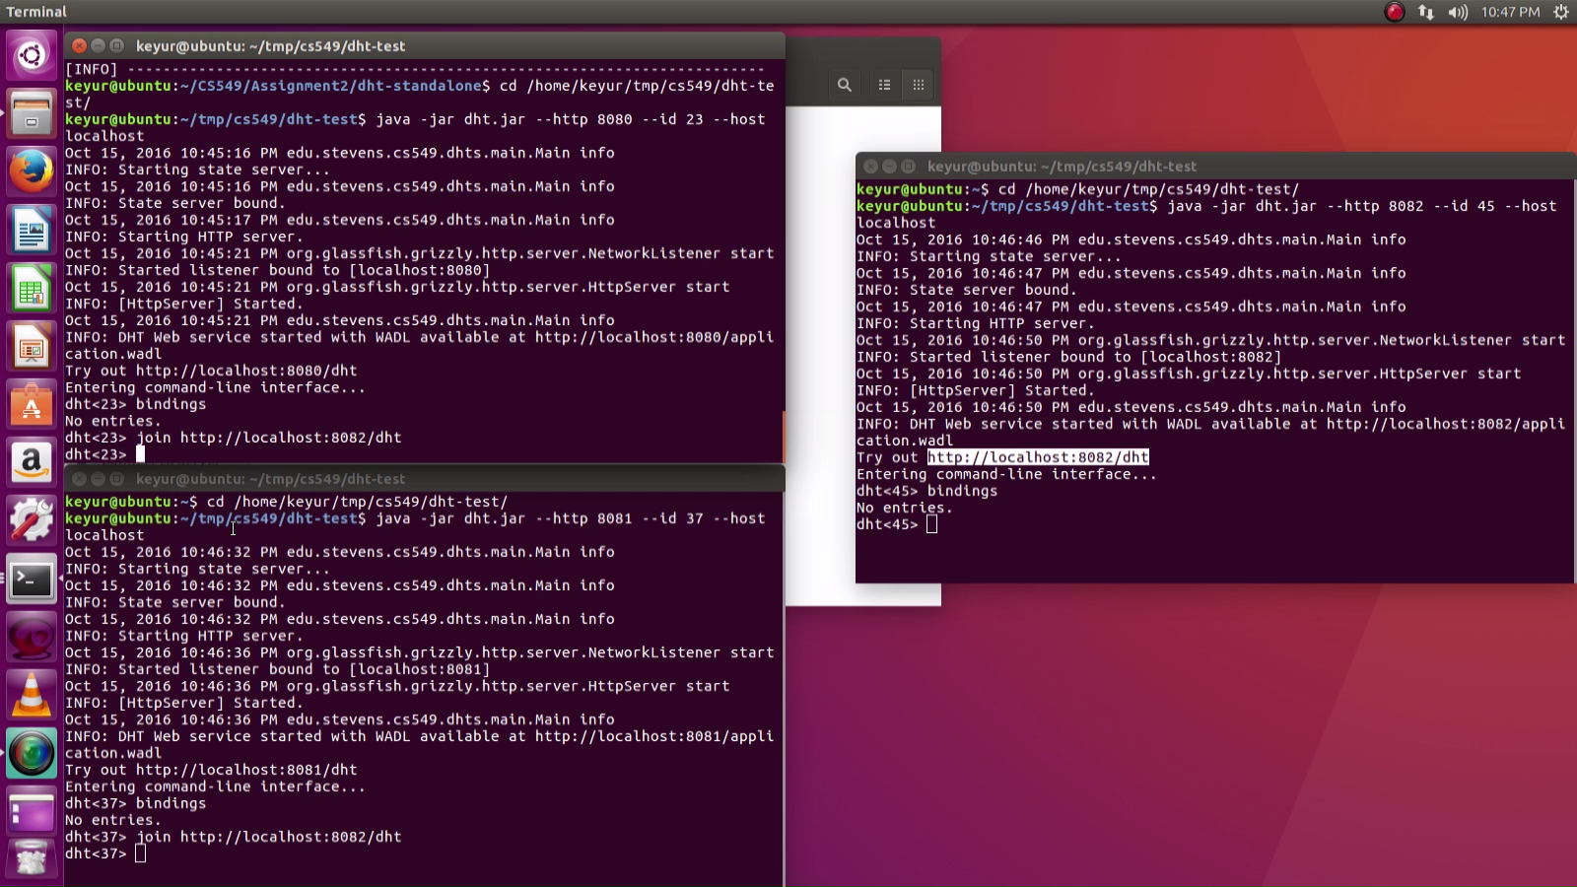

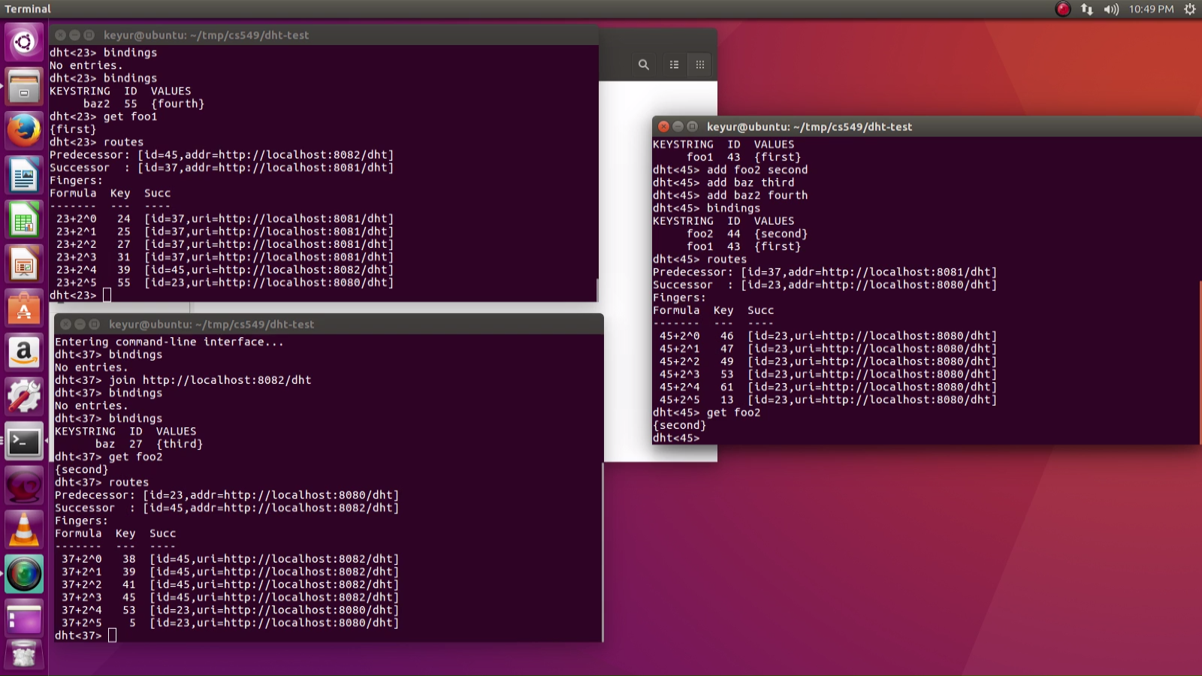

Connect Three nodes and bind them in Distributed Hash Table.

**java -jar dht.jar --http 8080 --id 23**

**java -jar dht.jar --http 8081 --id 37**

**java -jar dht.jar --http 8082 --id 45**

Join two nodes to the node listens 8082 port.

**Command: join** [**http://localhost:8082/dht**](http://localhost:8082/dht)

Routes to them with each other which tells you Successor and Predecessor.

Join to the first node by another two nodes and routes three points in DHT.

Add keys and values by **add [key] [values] command** and get keys by **get [key] command**

**delete keys by del [key] [values] command.**

Adding key on three nodes and get from three different nodes using Distributed Hash Table.

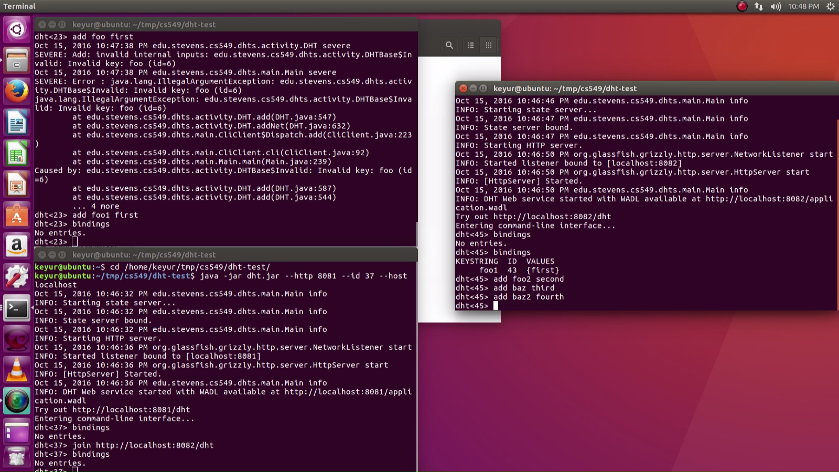

Performed Add, Delete, Bindings, Routes and Get operations In Distributed Hash Table with {key,Value} on three nodes.

**Remote Testing:**

Three ec2 instances created on Amazon web service and connect them through Secure Shell Script to communicate in DHT. Define security groups for instances.

**ssh -i /home/keyur/cs549-dht-keypair.pem ec2-user@ec2-52-90-165-161.compute-1.amazonaws.com**

Then Copy the dht.jar file using Secure copy command.

**scp -i /home/keyur/cs549-dht-keypair.pem /home/keyur/tmp/cs549/dht-test/dht.jar** [**ec2-user@ec2-52-90-165-161.compute-1.amazonaws.com**](mailto:ec2-user@ec2-52-90-165-161.compute-1.amazonaws.com)**: /home/ec2-user/tmp/cs549/dht-test/**

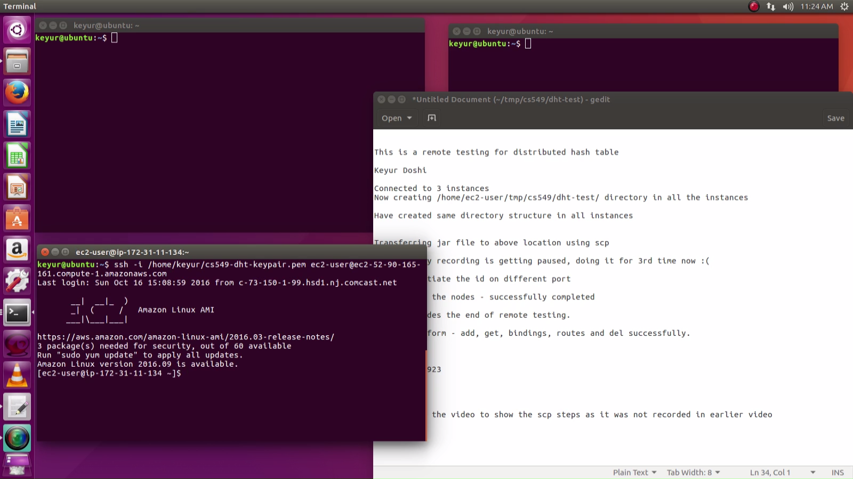

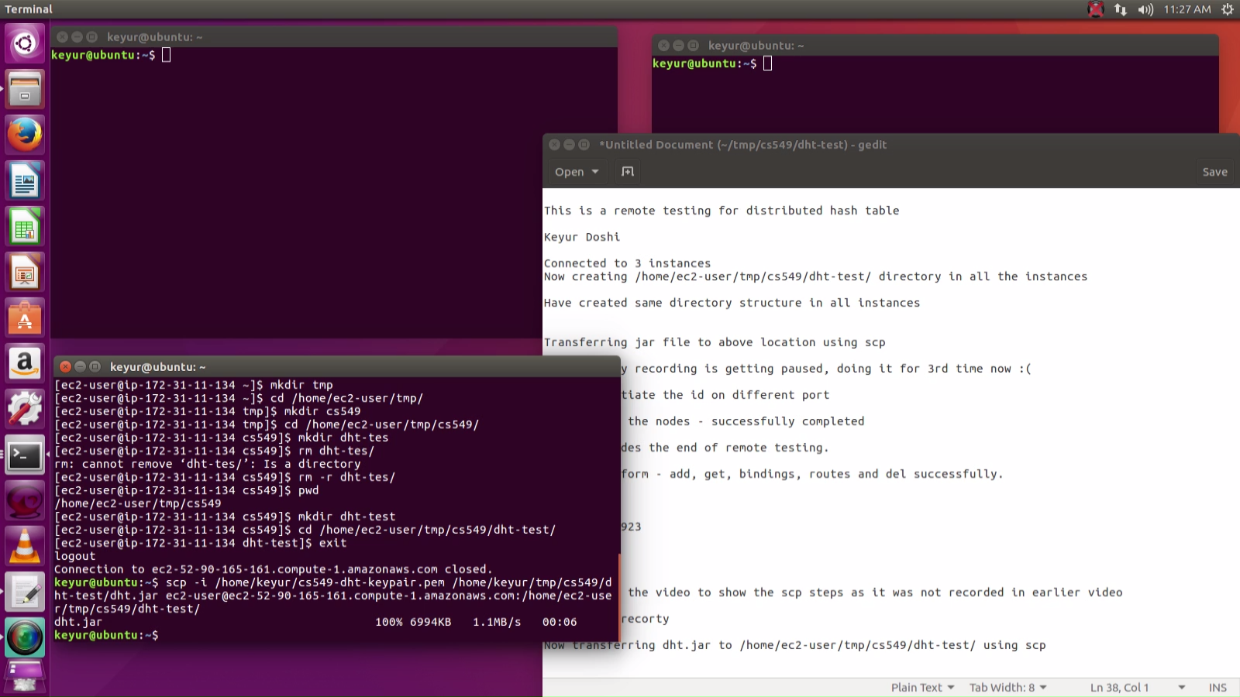

Connecting and joining nodes in remote servers.

Routes three nodes in DHT.

Add, Get, Delete keys and values using commands.

